1. **CSRF**: **C**ross **S**ite **R**equest **F**orgery.
   1. Means another origin makes request on behalf of you by making use of your cookies.
   2. Such as JSESSIONID is stored as a cookie which is sent by server to maintain a session with the logged in user.
   3. If someone else steals that JSESSIONID and makes request on your behalf, that person can steal your sensitive info.
   4. So, this request is being forged. That is why it is called “**C**ross **S**ite **R**equest **F**orgery”
2. 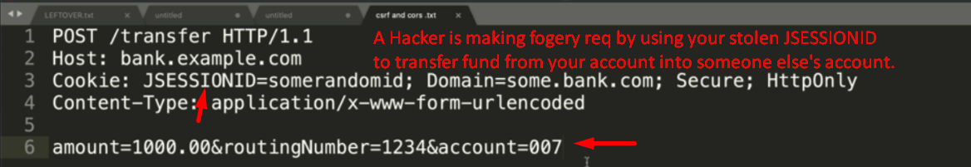
3. This is where CSRF comes in.
4. This is super easy in Spring App as when you add Spring Security Dependency, the CSRF is enabled by default.
5. 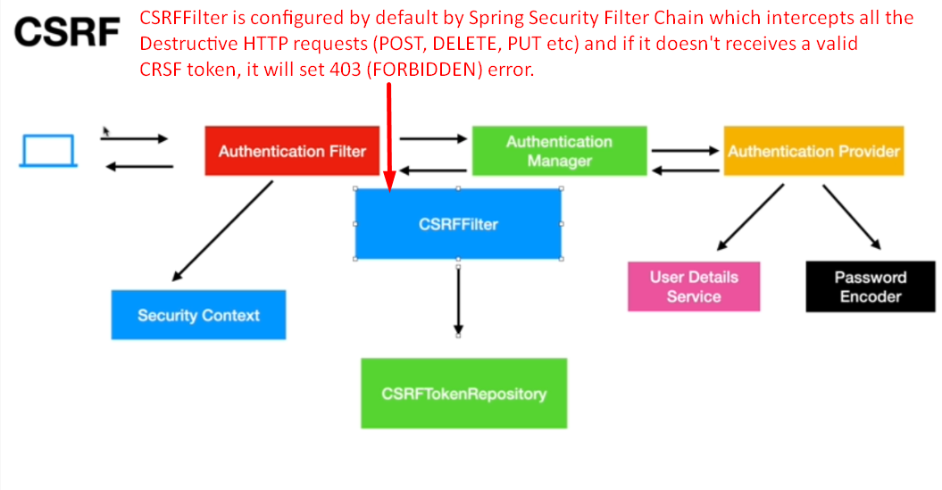
6. 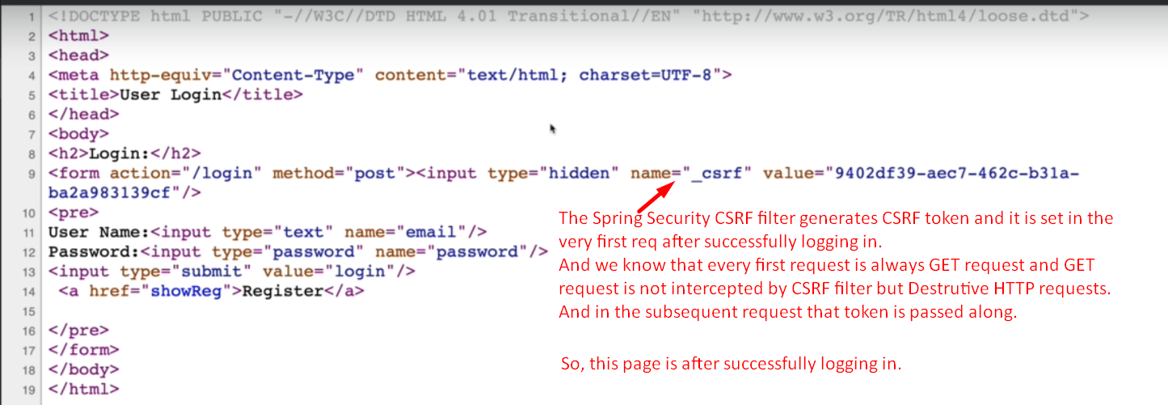
7. 